**NOISE POILLUTION MONITORING**

**Abstract:**

**Noise pollution is unwanted sound it needs to be controlled to make the workplace comfortable. This chapter analyses noise mathematically and the effects of multiple sources are examined. Two noises of exactly the same level can have a combined noise level that is 3 dB higher than the individual values.**

**Introduction:**

**Noise monitoring refers to the systematic process of measuring, recording, and assessing sound levels in various environments to understand the extent of noise pollution and its potential impact on human health and the surrounding ecosystem.**

**Noise pollution is considered to be any unwanted or disturbing sound that affects the health and well-being of humans and other organisms**

**Pollution refers to the harmful impact that unwanted changes happening in our environment have on our planet and its living beings like humans, animals, and plants.**

**When we talk about the introduction to pollution, we can say it is when the purity of our environment gets destroyed or contaminated.**

**Objective:**

**Noise monitors aim to provide data on noise levels for comparison with established limits in various environments such as road traffic, rail traffic, air traffic, and industrial plants. Noise monitoring equipment must meet specific requirements, including long-term stability and environmental robustness.**

**Components:**

**Noise is Monitored Using a Raspberry pi**

**A sound sensor can measure sound at different frequencies (called octave band analysis) and record sound clips to determine the source of noise pollution.**

**The method of noise level monitoring involves using specialized equipment, such as sound level meters or noise dosimeters, to measure and quantify the intensity of sound in a given environment.**

**The most basic is the Ambient Air Monitoring Program, which collects national air quality data on criteria pollutants: Carbon Monoxide (CO), Oxides of Nitrogen (NO2 and NO3), Ozone (O3), Lead (Pb), Particulate Matter (PM) - both particulates with aerodynamic diameters below 10 micrometers (PM-10) and particulates,**

**Block diagram:**

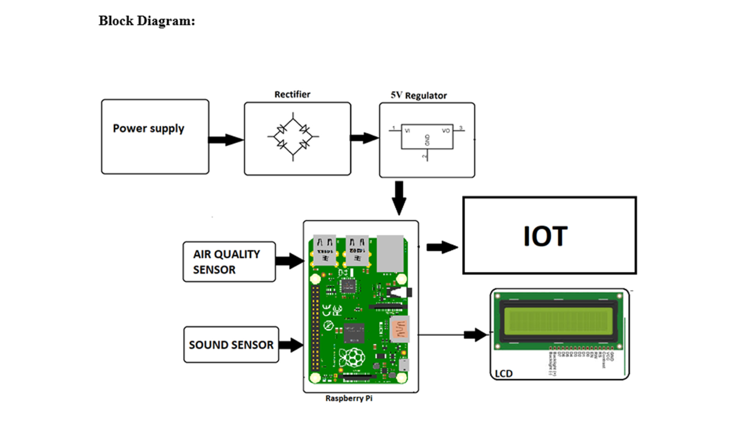

**Conclusion:**

**People thought that noise pollution is merely an annoyance but it is actually very important to monitor noise level because according to research, people who are exposed to noise for a long duration of time can have hearing loss, sleep disturbance, high blood pressure and injuries.**

**Noise pollution can cause health problems for people and wildlife, both on land and in the sea. From traffic noise to rock concerts, loud or inescapable sounds can cause hearing loss, stress, and high blood pressure.**